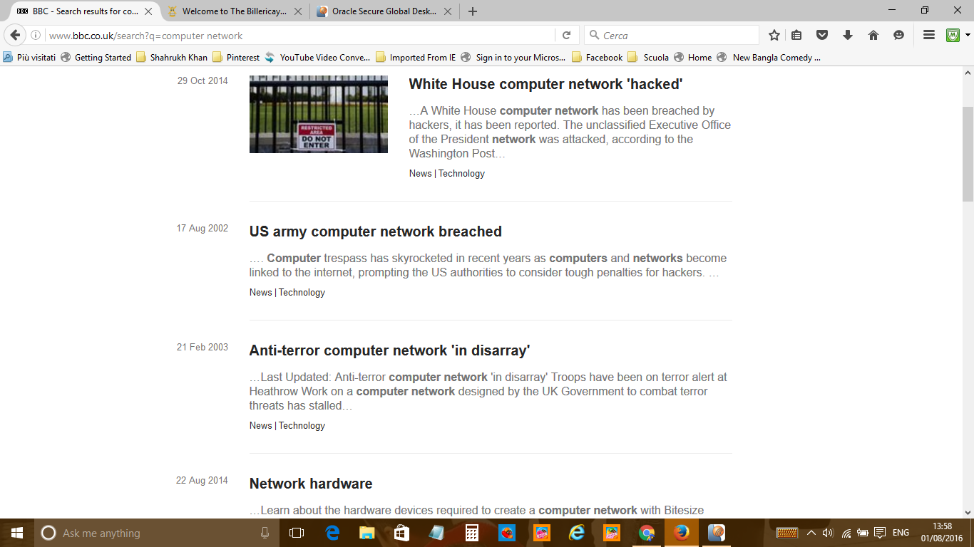

Taken 01/08/2016

http://www.bbc.co.uk/search?q=computer%20network

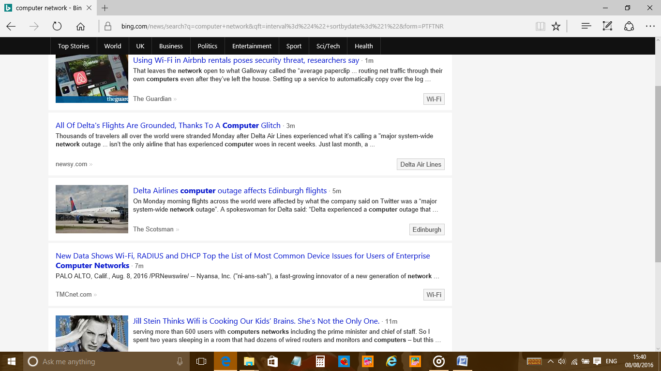

Taken: 08/08/2016

https://www.bing.com/news/search?q=computer+network&qft=interval%3d%224%22+sortbydate%3d%221%22&form=PTFTNR

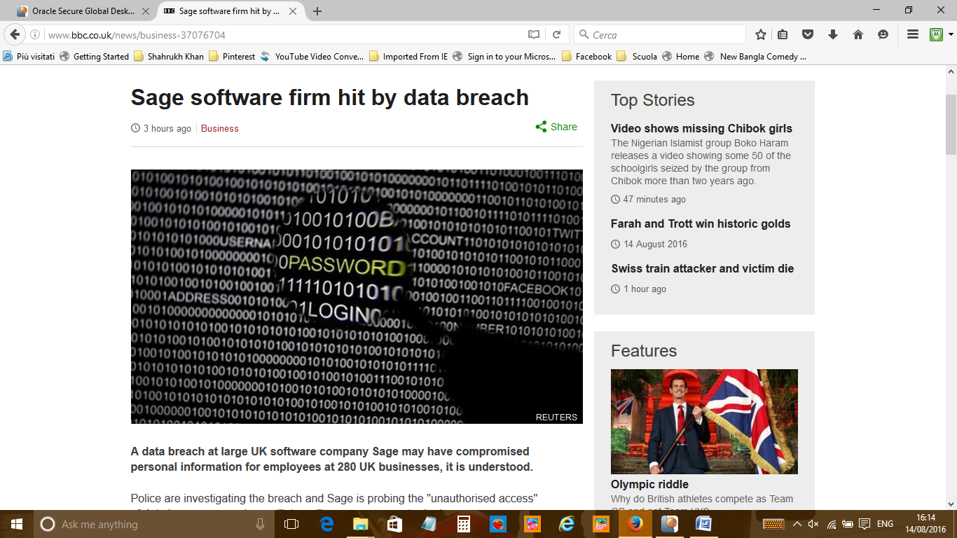

Taken: 14/08/16

http://www.bbc.co.uk/news/business-37076704

<https://www.bing.com/news/search?q=computer+network&qft=sortbydate%3d%221%22&form=YFNR> – 14/09/16